对外经济贸易大学
国际学院自助打印机操作手册

北京伟创星源科技有限公司
2024年1月

学生机器端使用操作手册

打印功能
Printing
- 机器端初始页面
Initial interface on the machine
点击打印图标开始使用，并确可以根据语言进行切换。
Select the printing logo to start, then can choose different language on the interface.
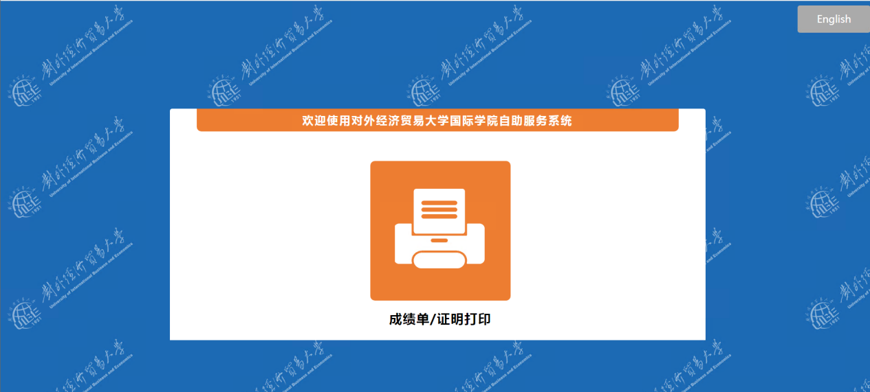
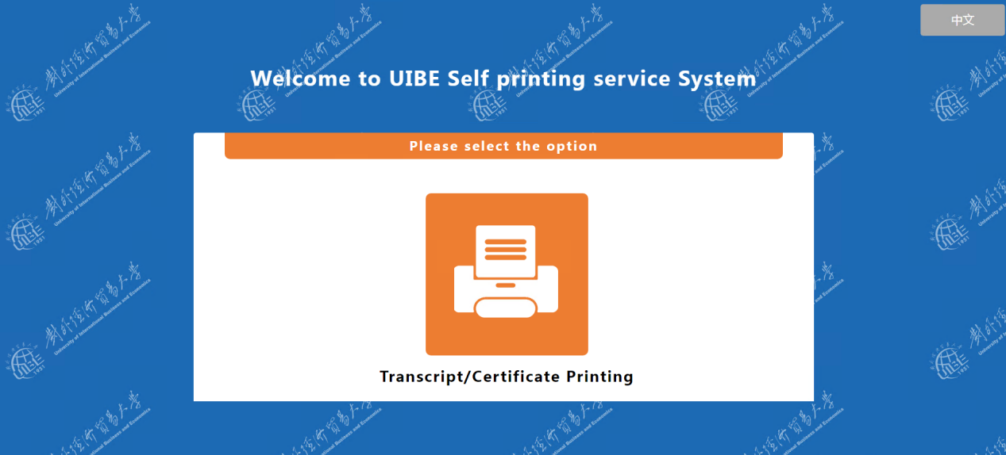
- 登录页面
Log in page
登录方式1：点击开始识别按钮通过人脸搜索登录系统（此功能需要学籍数据有相关照片，并且照片清晰度合格）
Method 1: Select start the facial recognizing by using your face to log in the system ( this function only can be used if the school system has your photo and the photo is clear enough)
登录方式2：点击学号登录，使用学号，出生日期作为账号密码登录系统，此方式对照片无要求，没有照片也可使用。
Method 2: Select student ID to log in, use the student ID and date of birth as the log in account password, this method don’t have any requirements on the photo, no photo also can be used.

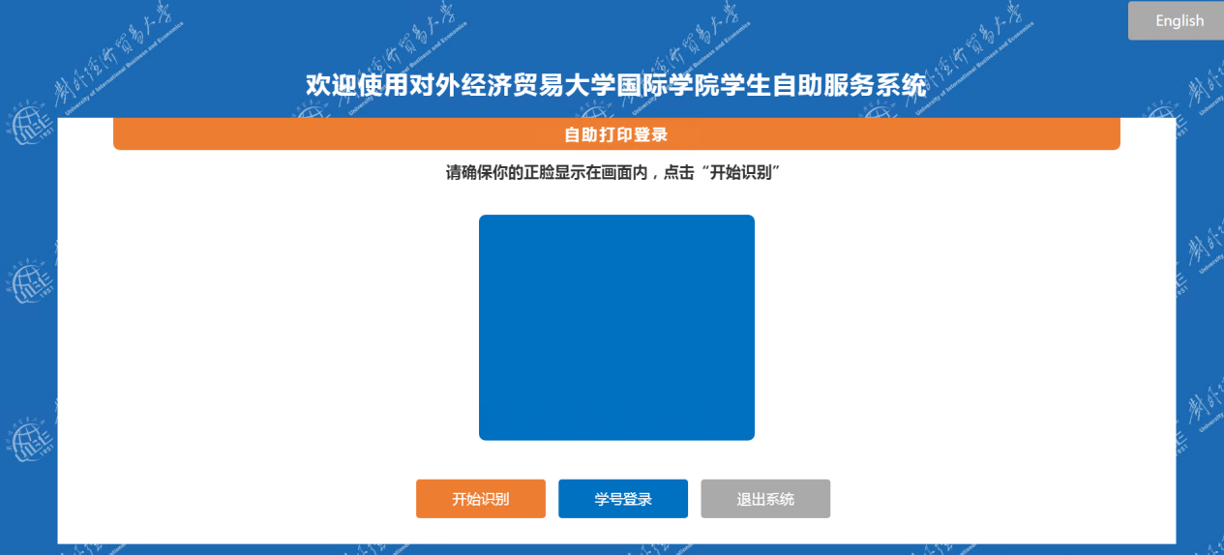
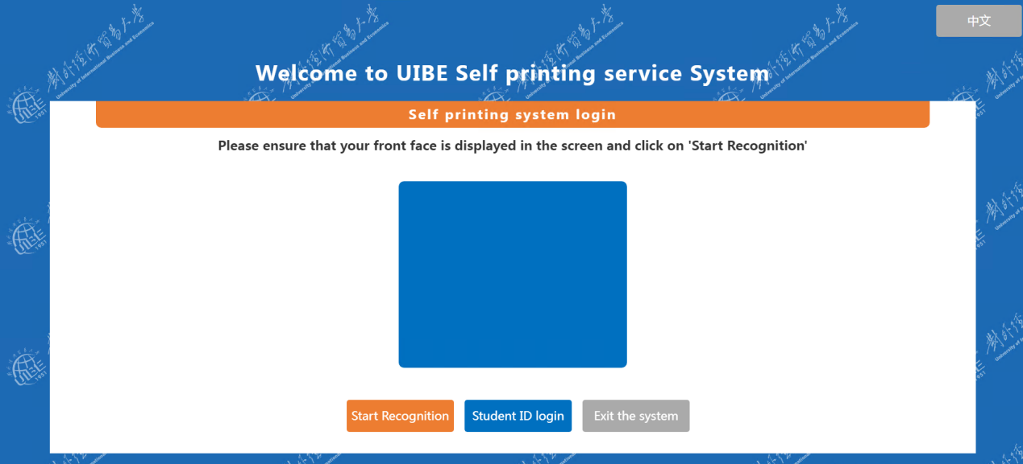

- 登录成功
Logged in successfully
完成登录后进入文件选择页面，右上角为个人信息以及免费打印次数，收费打印次数灯信息确认无误可以选择对应的文件进行预览打印，也可点击左下角充值页面进行额外次数的购买。（支付请见（6））
After logging in go to the files selection interface, on the left side is your personal information and numbers of free printing, numbers of paid printing. Confirm those information and then select which documents to print and preview it, also can select left corner to top up for extra documents printing fees. ( Payment information please refer to (6) )
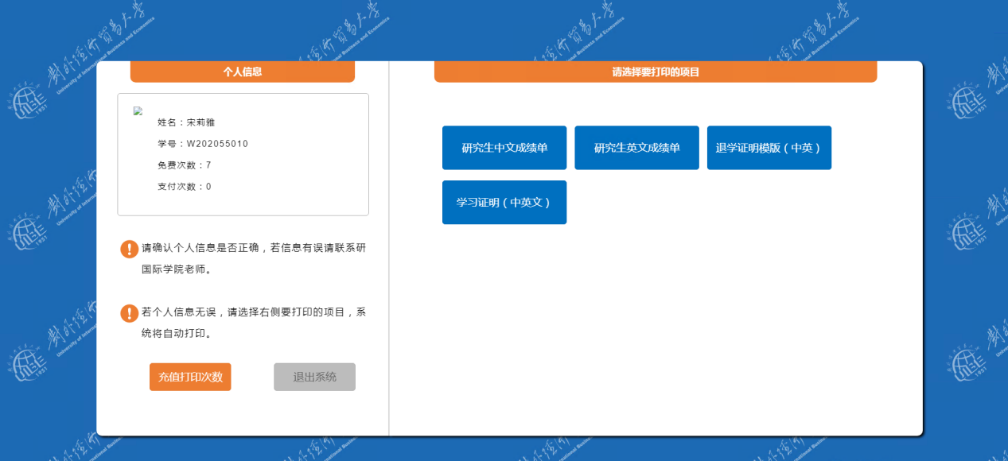
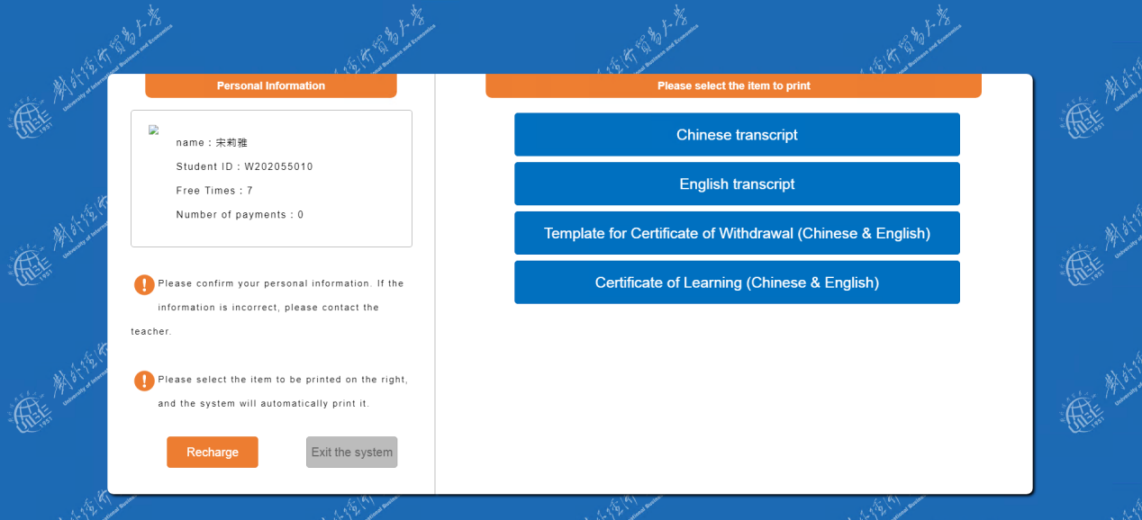

- 预览打印
Printing preview
文件生成无误并且相应次数可以使用进入到预览打印页面，点击打印按钮文件开始打印。
If the documents can be previewed and print, select the print button to start printing.
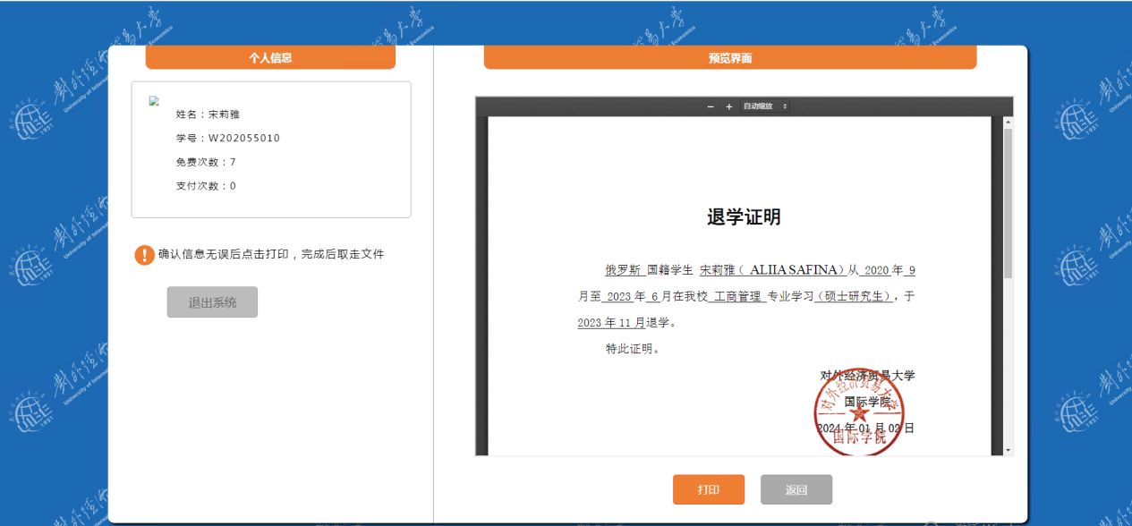
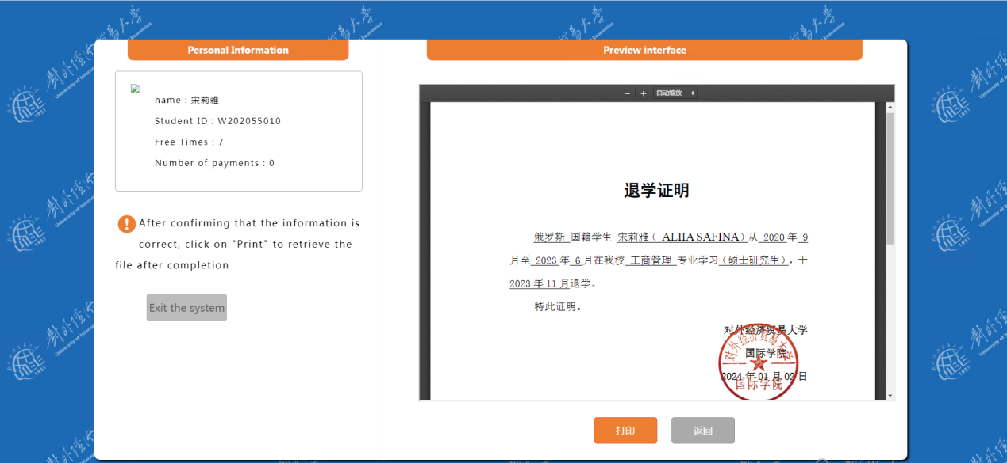

- 打印成功
Printing successfully
打印机正常工作，打印成功，可以推出或者继续打印
The machines works perfectly, successfully printed, can choose to quit or continue printing.

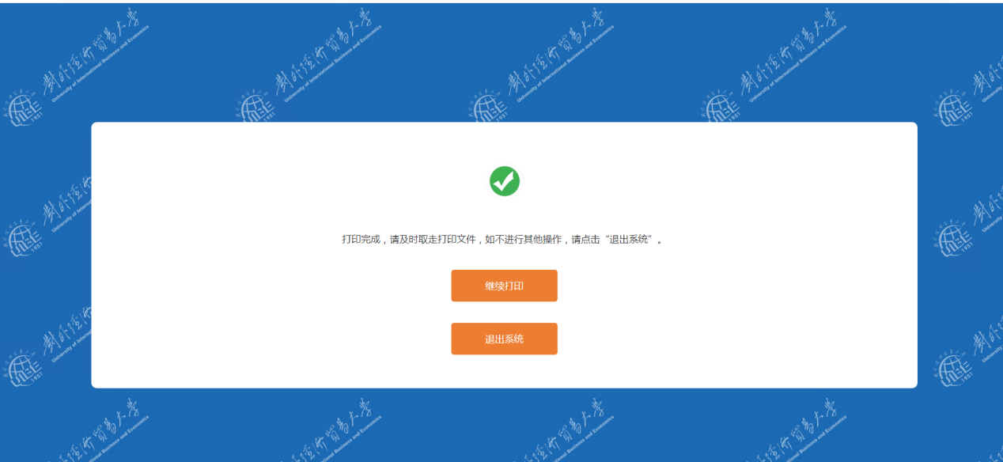
- 支付页面
选择需要购买的付费次数，点击支付后会刷新出相应的二维码，通过微信扫描支付后几秒钟页面会弹出支付成功的按钮，点击继续打印即可跳转选择页面继续使用打印功能。
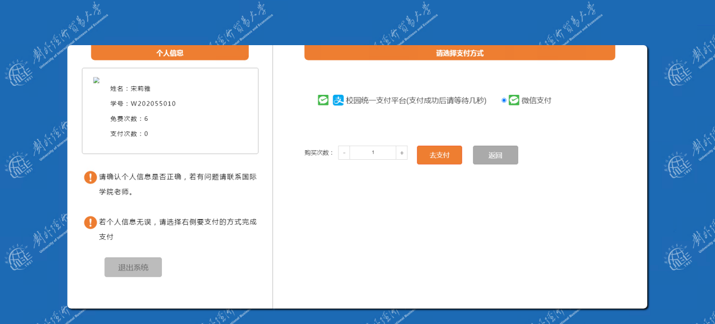
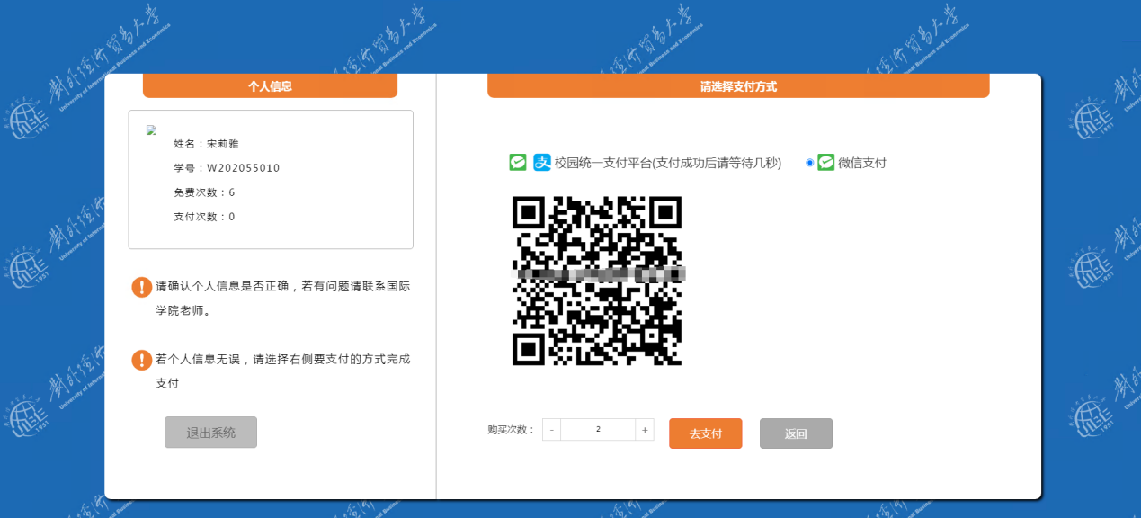
英文：