校内网上住宿登记操作流程

一、登陆网址:
https://zwfw.gaj.beijing.gov.cn/zsdj/zsdj-q/#/Announcement

扫描二维码


三、操作指南:
Step1：扫码或输入网址登陆，点击下一步
Scan the code or enter the URL login, click Next step
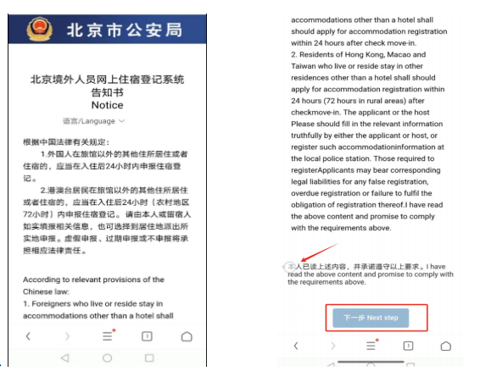

Step2：使用手机号码，验证登陆
Use the mobile phone number to verify the login
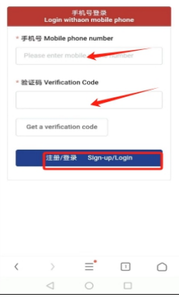

Step3：填入个人信息
Fill in personal information
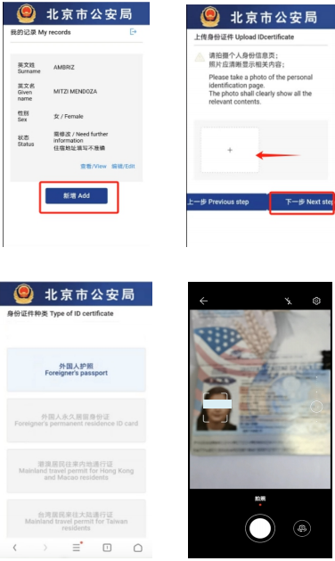

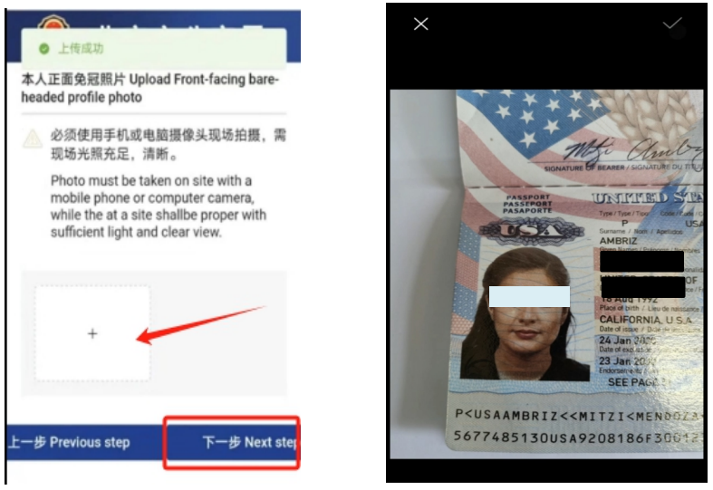

Step4：填入住宿地信息
Fill in the accommodation information
（校内居住的同学可以到A座前台申请纸质证明，自行拍照上传）
（Students living on campus can apply for paper certificates at the front desk of Block A, take photos and upload them by yourself）
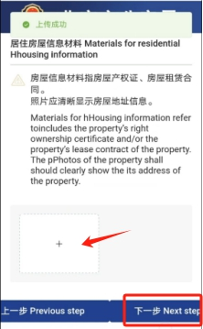

Step5：更新个人信息
Update personal information
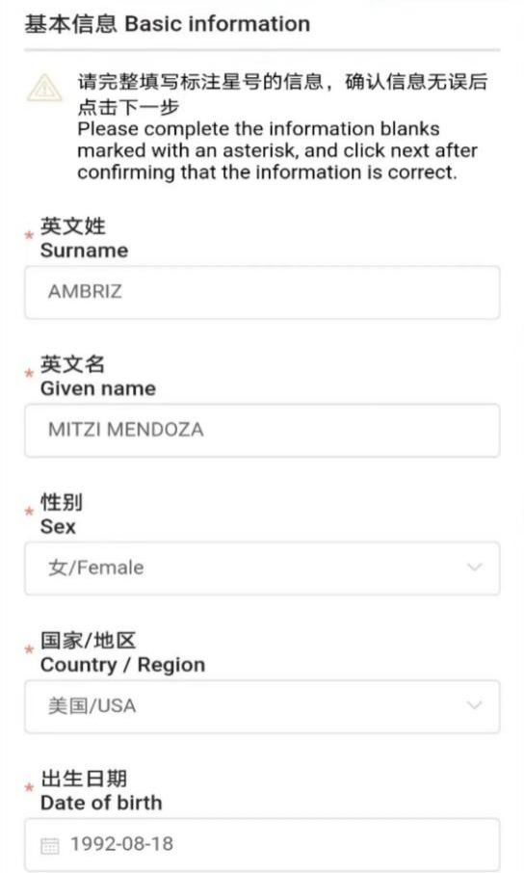
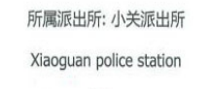
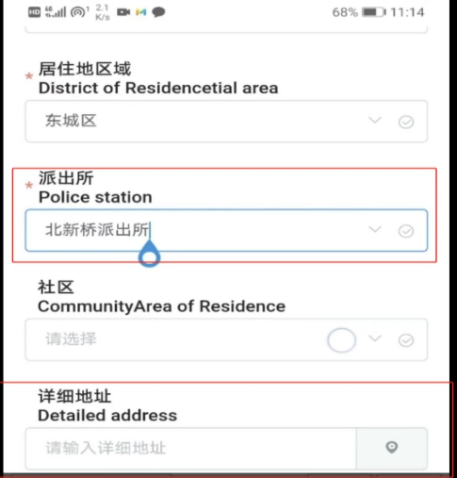
校内住宿的同学此项请选择小关派出所，校外住宿的同学可以询问房东房屋所在的辖区派出所名字。
For students who live on campus, please select Xiaoguan Police Station. For students who live off campus, please ask the name of the police station in the area where the host house is located.

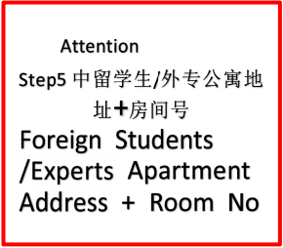

Step5复核更新结果
Review the update results
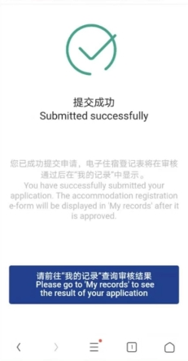
一定要在上传信息后去复核自己是否已经获得了电子住宿登记！
Be sure to check if you have obtained the electronic accommodation registration after uploading your information!

